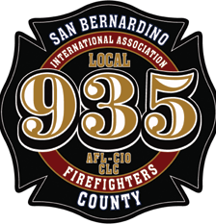

Dear

Honored Guest

San Bernardino County Professional Firefighters • Local 935 San Bernardino County Fire Protection District

FIRE OPS 101

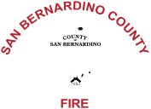

Local 935

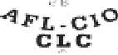

San Bernardino County Professional Firefighters Local 935 and the San Bernardino County Fire Protection District invite you to Fire Ops 101, an event offering elected and appointed officials as well as select media members a chance to step into a firefighter’s boots for a day.

Local 935 and the County Fire District together have long advocated for adequate staffing levels, and for firmly established specialty-skill resource programs, to ensure the citizens of and travelers to our county receive premiere professional help when emergencies occur.

Fire Ops 101 gives invitees a chance to experience exactly why those resources are needed, and to see how personnel from multiple companies come together to apply their skills in dynamic, often dangerous environments. Our event will feature the latest developments in fire, rescue and emergency medical services, as well as some of the broader issues concerning firefighter safety.

Local 935 personnel will construct challenging—yet controlled—scenarios offering experience in these situations. Participants will practice donning protective clothing and equipment and will enter a live structural fire demonstration. In addition, participants will experience the capabilities of our Truck Companies and handle vehicle extrication equipment such as the Jaws of Life.

This event promises to be exciting and informative and should provide some perspective on the shared mission between your Fire District and labor organization. We would be honored by your participation. Local 935 and the District will perform outreach to local and regional press so that your constituents know you stand with us on the front lines.

A light breakfast will be included, as will lunch to be provided by some of your San Bernardino County Firefighters.

This event will be held Dec. 6, 2023 from 8:00 a.m. – 2:00 p.m. at County Fire’s Richard Sewell Training Center located at 2824 West W Street in San Bernardino.

Please RSVP no later than Nov 1, 2023 at [www.sbcfireops101.com.](http://www.sbcfireops101.com/) In the meantime, if you have any questions, please contact either myself at (951) 852-2778, or Vice President Nic Turner at (909) 762-5357.

In your Service,

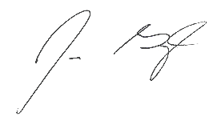

Jim Grigoli

President and Business Manager, IAFF Local 935

P.O. Box 1302 • Fontana, CA 92334