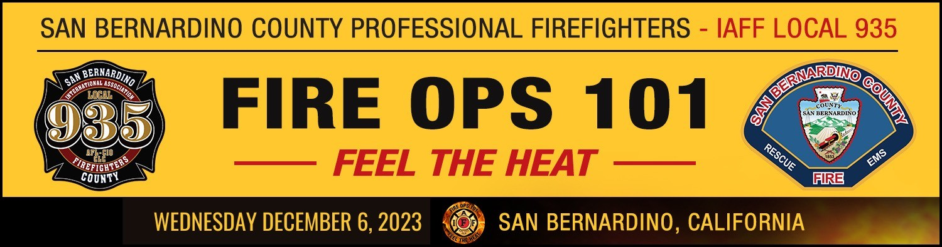

MEDIA ADVISORY

**FOR IMMEDIATE RELEASE CONTACT:**

Nic Turner IAFF Local 935

(909) 762 5357 (cell)

**SAN BERNARDINO, CA** -- *San Bernardino County Professional Fire Fighters IAFF Local 935, in partnership with the San Bernardino County Fire Protection District, will host FIRE OPS 101, a daylong program in which participants experience hands-on firefighting and rescue operations under the controlled supervision of professional Firefighters and Paramedics.*

**WHAT:** This workshop will demonstrate fire and emergency medical service operations, from suiting up in the proper protective gear to performing auto extrications to extinguishing fires. Each of the scenarios will give participants the opportunity to experience what our Firefighters and Paramedics face on a daily basis and see how challenging it is to keep our communities safe across 19,293 square miles of diverse terrain in San Bernardino County.

**WHO:** San Bernardino County Professional Fire Fighters IAFF Local 935 San Bernardino County Fire Protection District

City & County Elected Officials and Staff Members of the Media

**WHEN:**

Wednesday, December 6, 2023 **Participant Check-In:** 7:30AM **Workshops:** 9:00AM – 2:00PM

**WHERE:** Richard Sewell Training Center 2824 W Street

San Bernardino, CA 92415

**WHY:** Live simulations offer the chance to see, feel, and use the same equipment and protective gear that are vital to Firefighter safety. Participants will don self-contained breathing apparatus, battle a live fire, and will learn to recognize and respond to fire behavior events, such as flashover. In addition, they will learn about how County Fire Crews provide advanced life support to a victim of a heart attack and engage in technical rescue operations.

**REGISTER:** Visit [www.sbcfireops101.com](http://www.sbcfireops101.com/) to confirm attendance. Media outlets are invited to register a reporter to cover the event or to participate. Pre-registration is required by contacting Local 935.